|  |
| --- |
| Experiment No.2 |
| To Implement the concept of authentication of sender using Digital Signature |
| Date of Performance: |
| Date of Submission: |

**AIM:** To Implement the concept of authentication of sender using Digital Signature

**Objective:** To develop a program to create a digital signature for the sample input and verify it

# Theory:

A digital signature is a mathematical technique used to validate the authenticity and integrity of a message, software or digital document. It's the digital equivalent of a handwritten signature or stamped seal, but it offers far more inherent security. A digital signature is intended to solve the problem of tampering and impersonation in digital communications.

Digital signatures can provide evidence of origin, identity and status of electronic documents, transactions or digital messages. Signers can also use them to acknowledge informed consent.

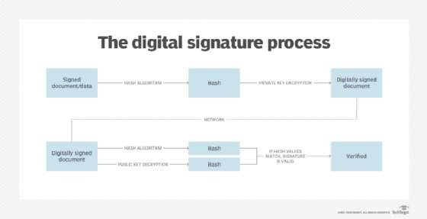

Fig. 2.1 Digital Signature Process

To create a digital signature, signing software, such as an email program, is used to provide a one-way hash of the electronic data to be signed.

A hash is a fixed-length string of letters and numbers generated by an algorithm. The digital signature creator's private key is then used to encrypt the hash. The encrypted hash -- along with other information, such as the hashing algorithm -- is the digital signature.

The reason for encrypting the hash instead of the entire message or document is a hash function can convert an arbitrary input into a fixed-length value, which is usually much shorter. This saves time as hashing is much faster than signing.

The value of a hash is unique to the hashed data. Any change in the data, even a change in a single character, will result in a different value. This attribute enables others to use the signer's public key to decrypt the hash to validate the integrity of the data.

If the decrypted hash matches a second computed hash of the same data, it proves that the data hasn't changed since it was signed. If the two hashes don't match, the data has either been tampered with in some way and is compromised or the signature was created with a private key that doesn't correspond to the public key presented by the signer -- an issue with authentication.

Role of Digital Signature in Blockchain: Digital signatures are a fundamental building block in blockchains, used mainly to authenticate transactions. When users submit transactions, they must prove to every node in the system that they are authorized to spend those funds, while preventing other users from spending them. Every node in the network will verify the submitted transaction and check all other nodes’ work to agree on a correct state.

# Process:

Step 1. Create a sample information on which digital signature is to be obtained Step 2. Generate Private-public key pairs for the sender and recipients

Step 3. Create Hash of the sample information using SHA-256 algorithm

Step 4. Encrypt the Hash using private key of the sender to obtain Digital Signature Step 5. Append Hash to the original sample information

Step 6. Encrypt the information obtained from step 5 using public key of recipient Step 7. Send the information (Cipher text) obtained from step 6 to the recipient Step 8. Decrypt the Cipher text using private key of the recipient

Step 9. Decrypt Digital signature using public key of the sender to obtain original hash as obtained by step 3

Step 10. Recipient perform hashing of the decrypted sample information in step 8 using SHA- 256 to obtain latest hash

Step 11. The latest hash obtained is then compared with the hash obtained in step 9 to authenticate the sender

# Conclusion:

The implementation of sender authentication through digital signatures is a vital security measure in the digital realm. It provides a robust means to confirm the sender's identity and verify the integrity of transmitted data. This technology is integral to secure email communication, online transactions, and document verification. By adopting digital signatures, we bolster cybersecurity, foster trust, and safeguard sensitive information in an increasingly digital world. It's a cornerstone of modern digital authentication and data protection.

CSDL7022: Blockchain Lab

# Output:

